**Task – 20**

**Pods and Services in Kubernetes Deployment**

**Launching ec2 instance:**

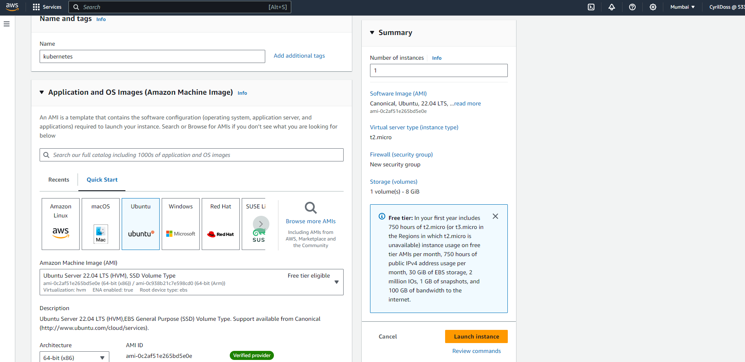

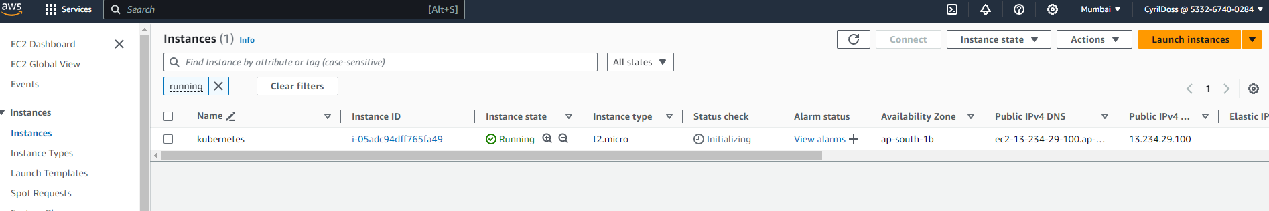

**Installing Aws Cli and configuring Aws cli:**

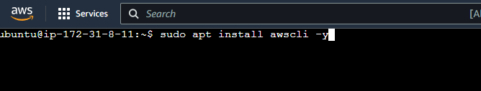

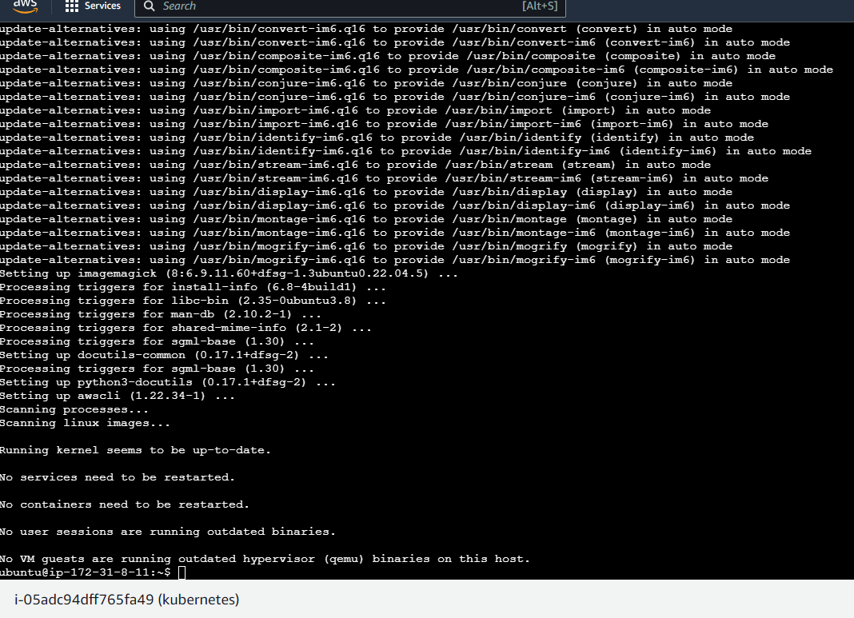

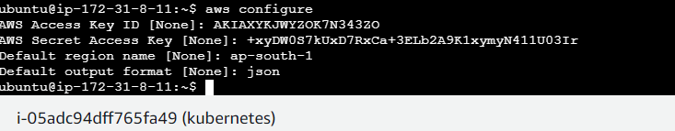

**Installing kubectl and eksctl:**

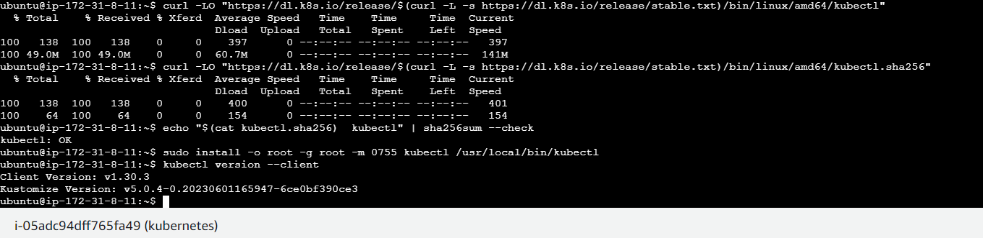



**Creating a cluster:**

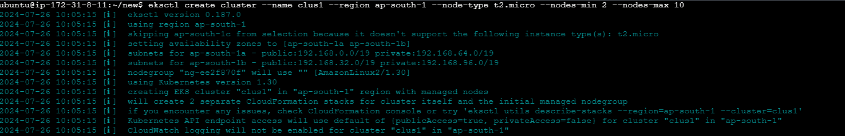

**Creating pod:**

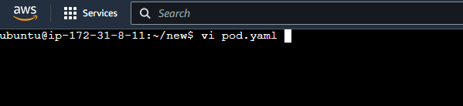

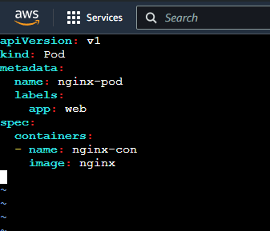

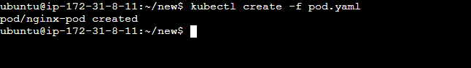

**Creating deployment:**

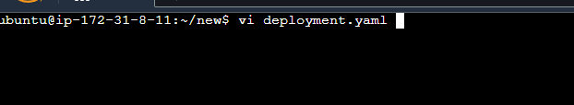

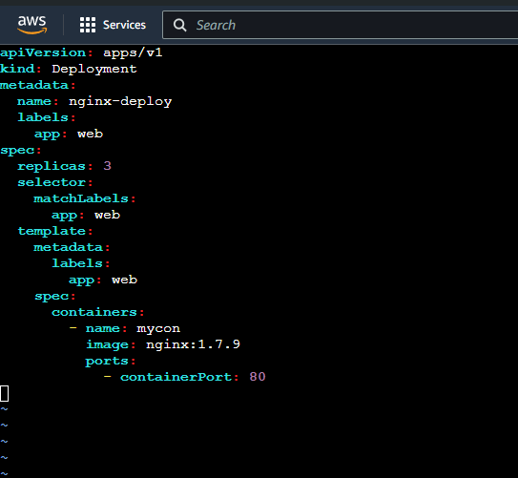

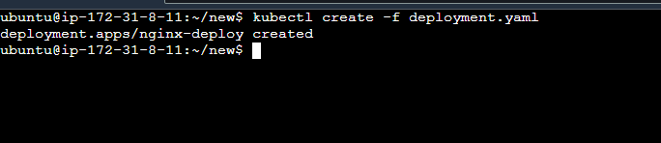

**Creating service:**

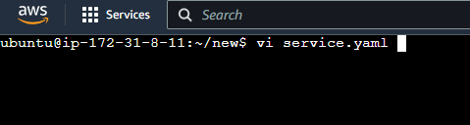

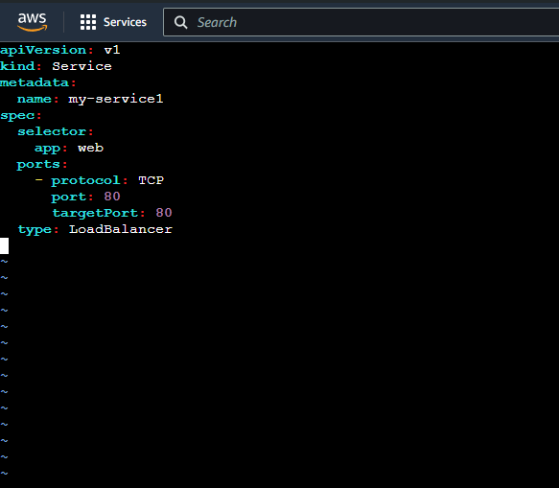

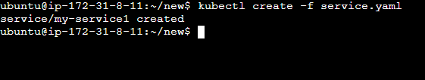

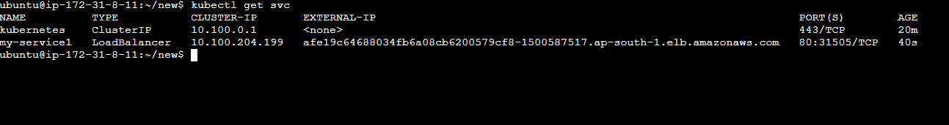

**Output of the cluster:**

